**Sequence Diagram:**

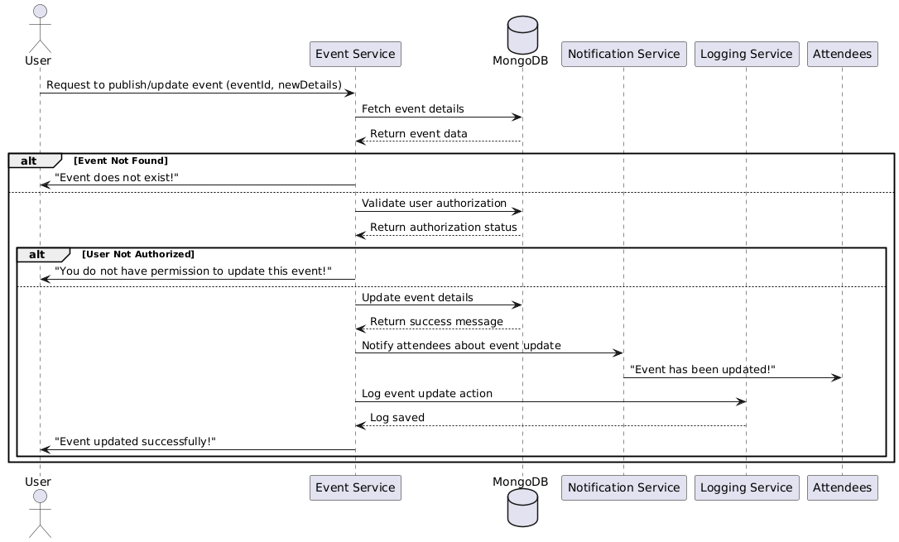

**Database**

**Functional Requirements (FRs)**

* **FR1:** Only the event creator or a group admin shall be able to publish or update events.
* **FR2**: The system shall allow modifying event details such as date, time, and location.
* **FR3:** The system shall notify registered users when an event is updated.
* **FR4:** The system shall log all event updates for tracking purposes.

**Non-Functional Requirements (NFRs)**

* **NFR7:** Event updates should be reflected in real-time.
* **NFR8:** The system shall use caching (e.g., Redis) to optimize event retrieval.
* **NFR9:** The event publishing feature must have 99.9% uptime.